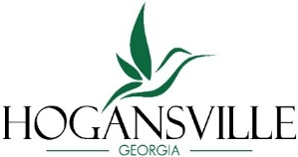
City of Hogansville
City Council
Work Session Meeting Agenda

Monday, April 20, 2026 – 6:00 pm

Meeting will be held at Hogansville City Hall
111 High Street, Hogansville, GA 30230
Mayor: Jake Ayers 2029 City Manager: Lisa E. Kelly
Council Post 1: Michael Taylor, Jr 2029 Assistant City Manager: Oasis Nichols
Council Post 2: Jason Baswell 2029 City Attorney: Alex Dixon
Council Post 3: Mandy Neese * 2027 Chief of Police: Jeffrey Sheppard
Council Post 4: Mark Ayers 2027 City Clerk: LeAnn Lehigh
Council Post 5: Kandis Strickland 2027 * Mayor Pro-Tem

WORK SESSION – 6:00 PM

BUSINESS
- Propose Rezoning – Parcel No. 0023001016 - Weaver Tract
- Preliminary Plat Application – HillStar Ridge – Chisel Mill Design & Build LLC
- Hummingbird Hollow – Final Plat
- Bid Award – LCRR Water Line Determination & Replacement

